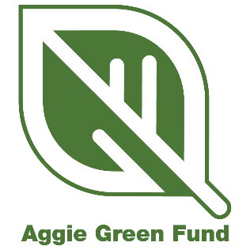
Micro-Grant Reporting - Progress Summary

*NOTE: All Aggie Green Fund reporting must be submitted via the appropriate WizeHive link. The following questions are provided for applicants to prepare answers prior to entering them in the WizeHive portal.

Project Title: Click here to enter text.
Primary Contact: Click here to enter text.
Primary Email Associated with Project: Click here to enter text.
Project ID: Click here to enter text.
Date of this Progress Summary: Click here to enter text.

Directions: Please summarize your project’s progress by answering the following questions and completing the budget table.

- What have you completed with your project so far?
Click here to enter text.

- What are you currently working on?
Click here to enter text.

- What remains to be done to complete your project?
Click here to enter text.

- Where are you at in your project timeline and when do you expect to complete your project? How does this compare to the timeline you submitted in your application?
Click here to enter text.

- What obstacles, if any, have you encountered?
Click here to enter text.

- Please attach pictures showing your current progress. Submitting at least two pictures is required, but up to five may be submitted. These should be high-quality images and may be used on the Aggie Green Fund website, social media, reports, or presentations. You can see the required specifications for photos here.

- Total amount requested from the Aggie Green Fund:
Click here to enter text.

- Please download the budget template here. Fill out the template to reflect your original budget request and up-to-date fund usage. Please upload your updated budget sheet.

- Please upload your updated Score Card. This should reflect current metrics for your project. You can download the template here.

