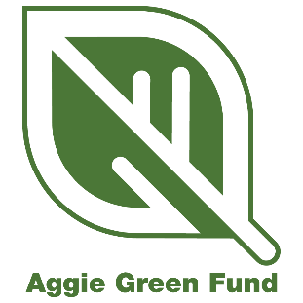
Major Grant Reporting - Final Report

*NOTE: All Aggie Green Fund reporting must be submitted via the appropriate WizeHive link. The following questions are provided for applicants to prepare answers prior to entering them in the WizeHive portal.

Project Title: Click here to enter text.
Primary Contact: Click here to enter text.
Primary Email Associated with Project: Click here to enter text.
Project ID: Click here to enter text.
Date of this Final Report: Click here to enter text.

Directions: Please summarize your project’s progress by answering the following questions, completing the budget table, and filling out the Score Card update.

- What has your project accomplished?
Click here to enter text.

- In the future, do you plan to apply for an additional grant to expand on your current project?
Click here to enter text.

- What obstacles, if any, did you encounter during the duration of your project and how did you overcome them?
Click here to enter text.

- How does your final project timeline compare to the timeline you submitted in your application? Please explain any major discrepancies.
Click here to enter text.

- Are there any remaining funds that will need to be returned to the Aggie Green Fund?
Click here to enter text.

- How much funding remains?
Click here to enter text.

- Any additional comments on your Aggie Green Fund Major Grant experience:
Click here to enter text.

- Please attach pictures of your completed project. Submitting at least five pictures is required, but up to ten may be submitted. These should be high-quality images and may be used on the Aggie Green Fund website, social media, reports, or presentations. You can see the required specifications for photos here.

- Please provide any web links to online content related to your project. Also list any social media accounts that feature your AGF project.
Click here to enter text.

- Total amount requested from Aggie Green Fund:
Click here to enter text.

- Please download the final budget template here. Fill out the template to reflect your original budget request, up-to-date fund usage, and any remaining grant funds. Please upload your completed final budget sheet.

- Please upload your updated Score Card. This should reflect final metrics for your project. You can download the template here.

